**JSON Arrays:**

* Values in JSON Can be arrays
* incomplete
* surrounded by “Square Brackets []”
* JSON Arrays values is separated by a comma
* Array values must be a void JSON data type
* (String, Number, Object, Array, Boolean or null)
* **Example:**

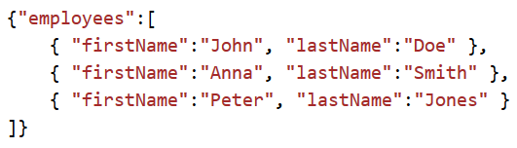

**Example 2:**

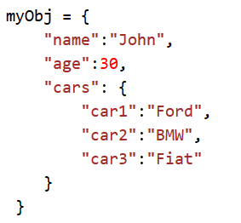

* Values in an array can also be another array, or even another JSON object:

{

“name” : “Praveen”,

“age” : 33,

“cars” : [

{ “name”:”GM”,

“models”:[“Aveo”,

“Beat”,

“Cruze”

]

},

{ “name”:”Audi”,

“models”:[“A3”,”A7”]

}

]

}